**Group Project Report**

# I. Project Overview

Doctor Today is a London-based private medical clinic that is committed to providing high-quality independent healthcare services to individuals, families, and companies at reasonable cost. Like many other clinics, Doctor Today has faced challenges with its current website's limitations. One of the most frustrating issues is the appointment request system, which is out of sync with the clinic staff’s calendars. As a result, patients often mistake a request for an appointment as confirmation, only to be disappointed upon arrival at the practice when they learn that they have not secured a slot. Also, the shift in user base from desktop to mobile devices has rendered the UI design unsuitable, making it difficult for patients to navigate. This issue may even dissuade some patients from seeking healthcare services here, as they may perceive the outdated design as unprofessional. Another issue faced by the practice is the heavy backlog of emails while their staff being overwhelmed with daily work. This often results in delays in responding to patient inquiries. Furthermore, the current website systems cannot be easily modified by clinic staff without knowledge of web applications. This technical obstacle has led to inefficiencies and delays in updating important information, such as holiday opening hours or changes in services provided.

To address the mentioned issues, our project aims to design and implement a web system that is built on modern web frameworks and enhances the user experience for both clinic staff and patients. Specifically, for patients, the system will streamline the appointment process, ensuring that the appointment request system is in sync with the doctor's calendar, preventing any confusion or frustration for patients. The system also enables real-time communication with the clinic staff via a chat functionality and supports easy navigation on any device. Meanwhile, for clinic staff, the system will have an admin portal in the format of dashboard, which will allow for easy content updates, such as adding new service offerings and corresponding pages, adjusting service prices, and updating practice information, without requiring any knowledge of web development. In addition, the system will be implemented with Search Engine Optimization in mind as it helps improve the website's visibility and ranking on search engine results pages, ultimately making it easier for potential patients to find the clinic's services.

Our project has made significant contributions, including:

* Created a modern, user-friendly website that smoothly integrates several external services, resolves critical appointment scheduling issues, and provides all the functionalities of the original website.
* Built a customizable content website with an admin portal that enables clinic staff to freely edit content without any technical expertise.
* Developed a responsive website with a mobile-first design that guarantees compatibility with various devices and browsers, ensuring seamless user experience across different platforms.

Further details regarding design elements and relevant feature implementation are provided in the following section.

# II. Website Design and Features

After conducting a detailed analysis of the [clinic’s current website](https://www.doctortoday.co.uk/) to identify areas of improvement and visited the clinics to gather requirements from the clinic staff. Using this information, we developed a comprehensive list of requirements to guide the website development process. Here is the link to our website running in production: <http://doctor-today-app.herokuapp.com/> and version control repo: <https://gitlab.doc.ic.ac.uk/g227004216/DoctorToday.git>

A. Architecture Design

The web system is designed to be compatible with various touch devices, including tablets and smartphones. Figure 1 shows the architecture of website development. The system will be deployed on a cloud-based platform which enables clients to launch their website quickly and efficiently. In terms of the architecture, we have opted for Nuxt.js as the framework for the front-end views and functionality of our architecture as it bridges the gap between single page applications (SPAs) and server-side rendered (SSR) applications, allowing us to apply different routing rules to our pages using hybrid rendering. For the backend development, we chose Node.js, while MySQL is used for data management and AWS S3 for image management. By utilizing these technologies, we aim to develop a robust and user-friendly system that will enable clinic staff to manage their website and booking system with ease.

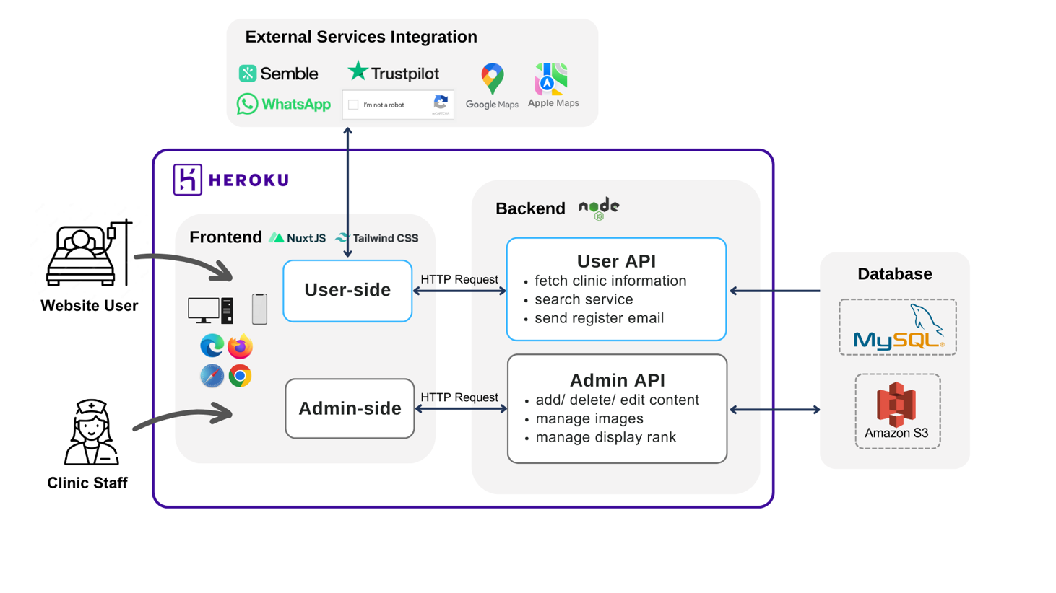

Figure 1: website architecture diagram

## B. Features Implementation

## *1) Configurability (backend & admin portal)*

One of the key requirements of the clinic is the ability to configure the content of the website on demand, while not needing any technical expertise. We created an admin portal that is user-friendly and intuitive to use, and staff members can easily modify, add or remove information from the website via this portal.

As demonstrated in Figure 2, the clinic staff can conveniently modify the information displayed on the website. They can add new content, remove existing content, and edit the current content as needed. Additionally, they can adjust the order in which the content is displayed by altering its rank or position on the website.

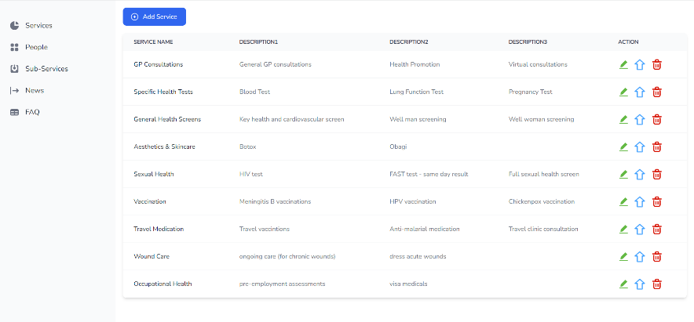 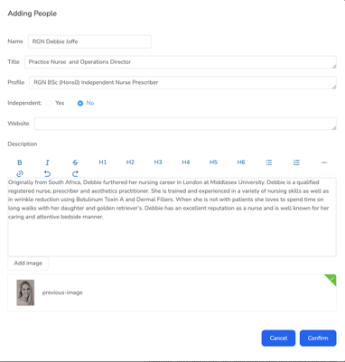

Figure 2: admin portal dashboard

Moreover, files stored on Heroku's filesystem are ephemeral, which means they can be lost if the dyno is restarted or moved. Thus, we use AWS S3 (Simple Storage Service), a cloud storage service offered by Amazon Web Services, for uploading images in admin portal and retrieving them from user end. After an image is uploaded to the portal, it will be stored in AWS, and the URL required to access the image will be saved in the MySQL database. When it’s edited or deleted, both URL in the database and images on AWS will be updated accordingly.

## *2) Integration with external services*

## 

Figure 3: external services integration

*3) Mobile First Design*

We implemented a responsive design to ensure mobile compatibility and browser compatibility. It works on most of the popular browsers, including Chrome, Safari, Edge, and Firefox, with consistent layout and features.

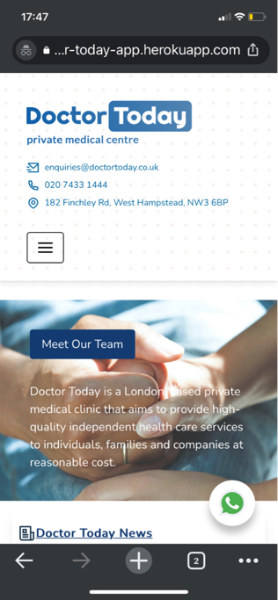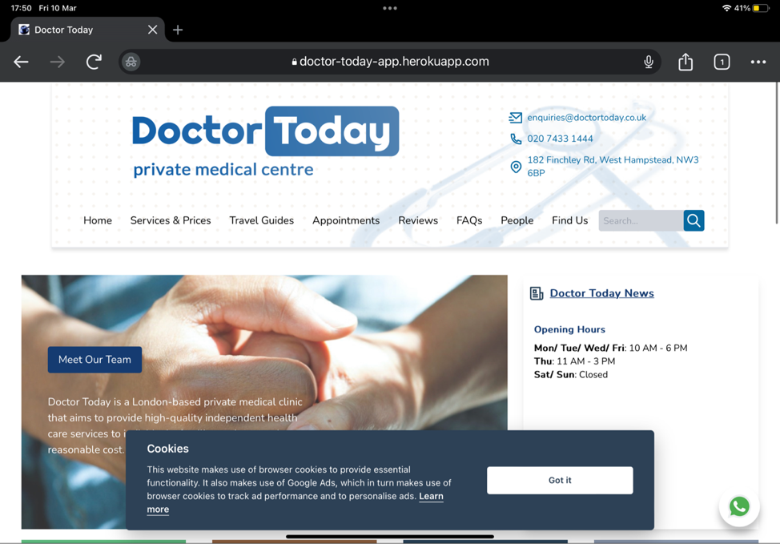

Figure 4: website display on mobile and tablet screen

*4) Email Service*

Our team has taken proactive approaches to safeguard the privacy and personal data of clients through the development of our registration email service. To ensure compliance with GDPR regulations, we have included consent requests in our registration process, providing clients with a clear understanding of how their personal data will be used and giving them the opportunity to opt-in before completing the registration process. In addition, we have implemented reCAPTCHA to prevent bot access to our registration process. Finally, we have opted to use Nodemailer for the delivery of registration emails to users.

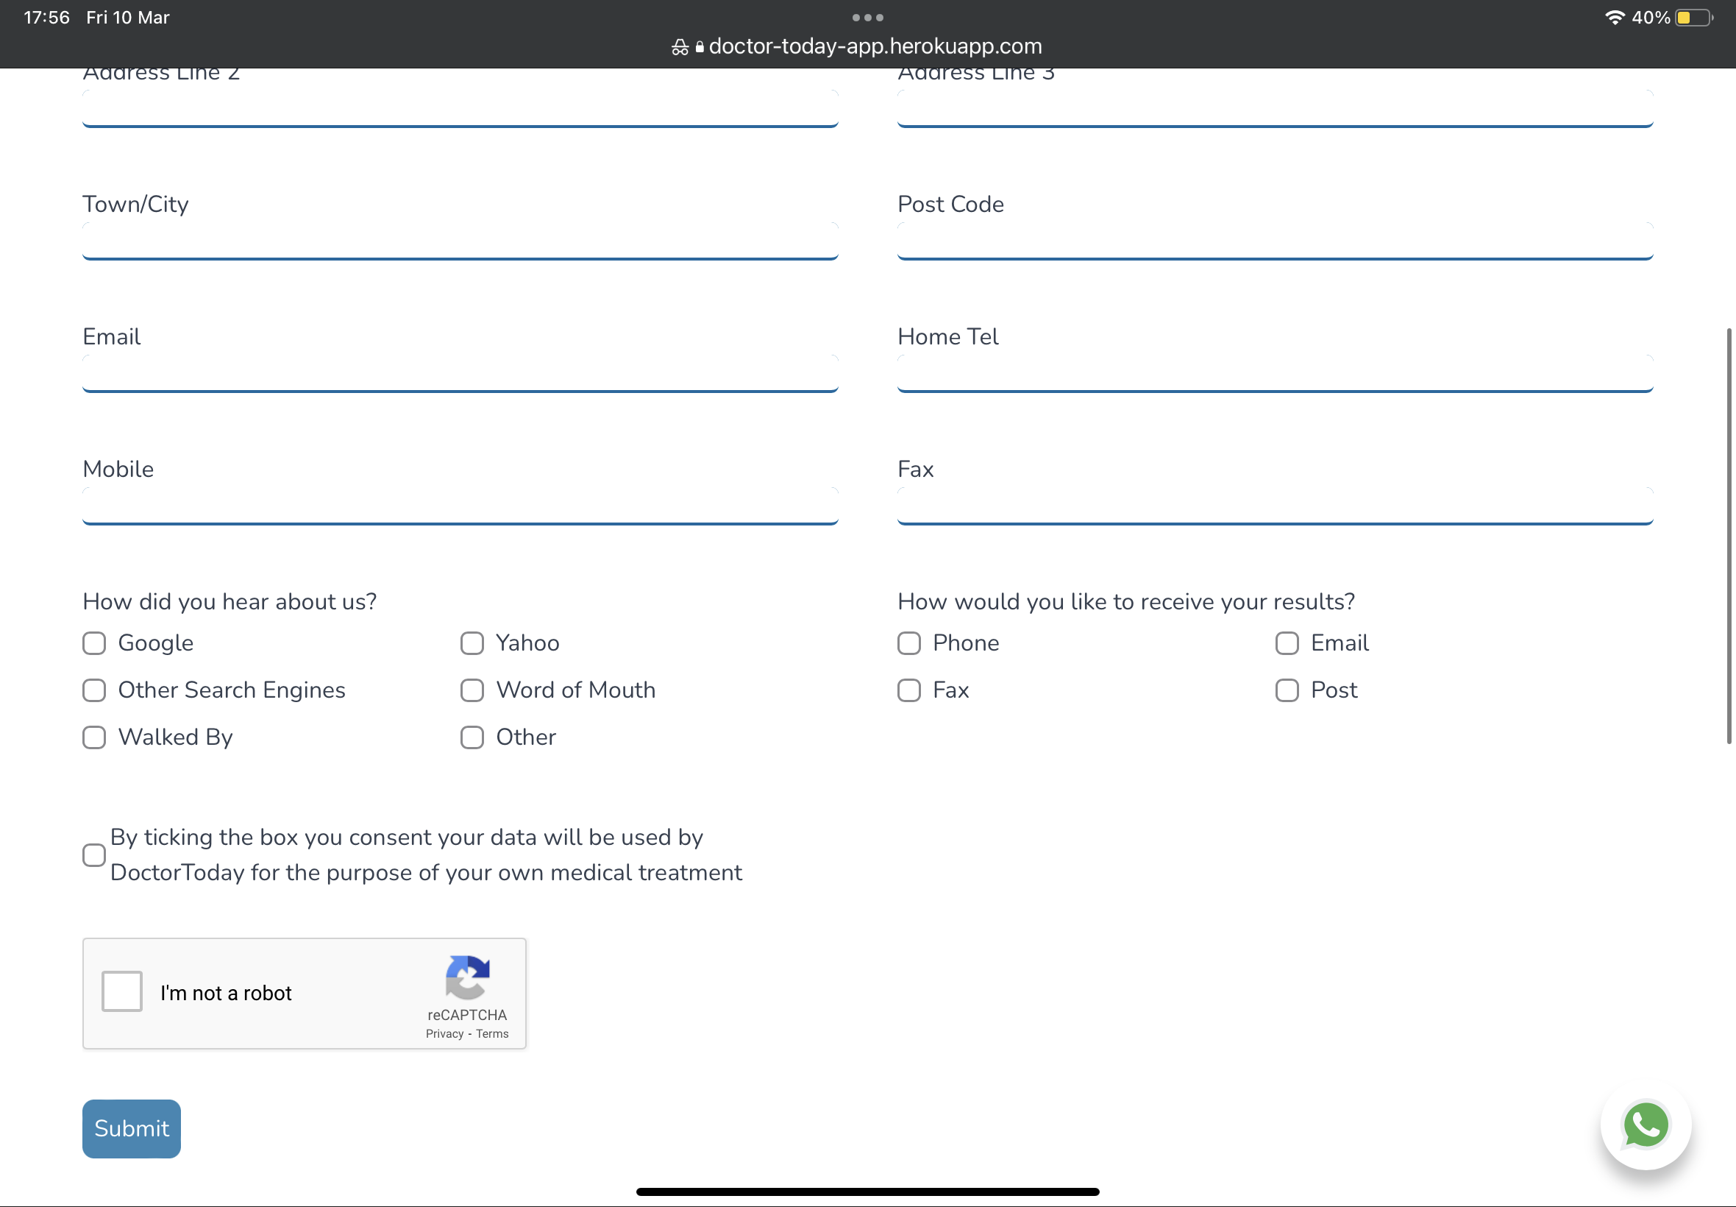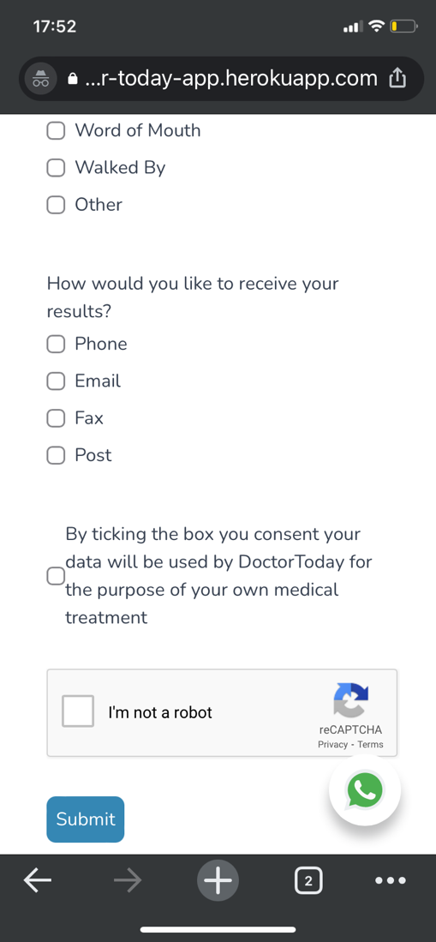

Figure 5: reCAPTCHA and GDPR tickbox on registration page

*5) Search*

Due to regulatory requirements from Care Quality Commission (CQC), clinics need to provide clear and detailed information about their services to patients on their website. This often results in lengthy descriptions and layers of tabs shown to patients. To help prospective customers navigate the site, we implemented a keyword search feature for site-wise search. By reducing the time and effort required to find information on the website, this functionality can significantly improve the user experience.

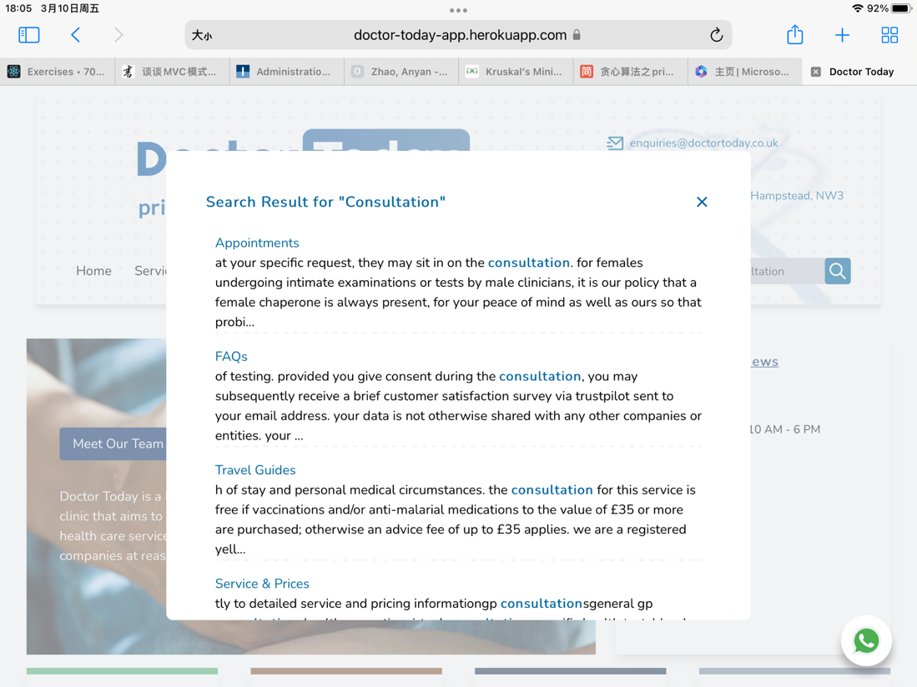

Figure 6: search page

# III. Evaluation

In summary, the new web system for Doctor Today has been successfully developed and implemented. The system has addressed the limitations of the current website, responding to the key concerns, and provided a more user-friendly and efficient platform for both staff and patients. Specifically, the system includes integration with various external services such as Semble, WhatsApp and Trustpilot to improve the smoothness of user experience for patients. The deployment process was smooth and successful, and it has already received incredibly positive feedback from staff and users. For example, one of the IT consolers from Trustpilot said he loved the refreshed look of the website and highly recommended our way of integrating different services. What’s more, the testing process was rigorous, and all identified issues were addressed and resolved in a timely manner. Overall, the new web system provided a significant improvement to the quality of Doctor Today healthcare clinic.

The biggest strength of our product is that it is totally flexible and customizable, 13 out of a total of 15 pages can be configured via the dashboard inside admin portal, so staff from the clinic can easily update and maintain their website. Another strength is the integration of different services, which makes the website more user-friendly and satisfies clients’ needs. Finally, the web system developed is nearly complete and is hosted on Heroku right now, thus requiring minimal additional effort to deploy the web app for actual usage under the clinic’s domain.

This web system is currently deployed in Heroku and can be published to a custom domain and replace the existing website. Another future work is that the remaining static web pages can also be converted into dynamic web pages so that we can migrate the website for another clinic with minimal development effort. Any clinic can easily set up their own customized websites using our web system.